# **Analyse International Debt Statistics**

(Wireframe Documentation)

**Dashboard**

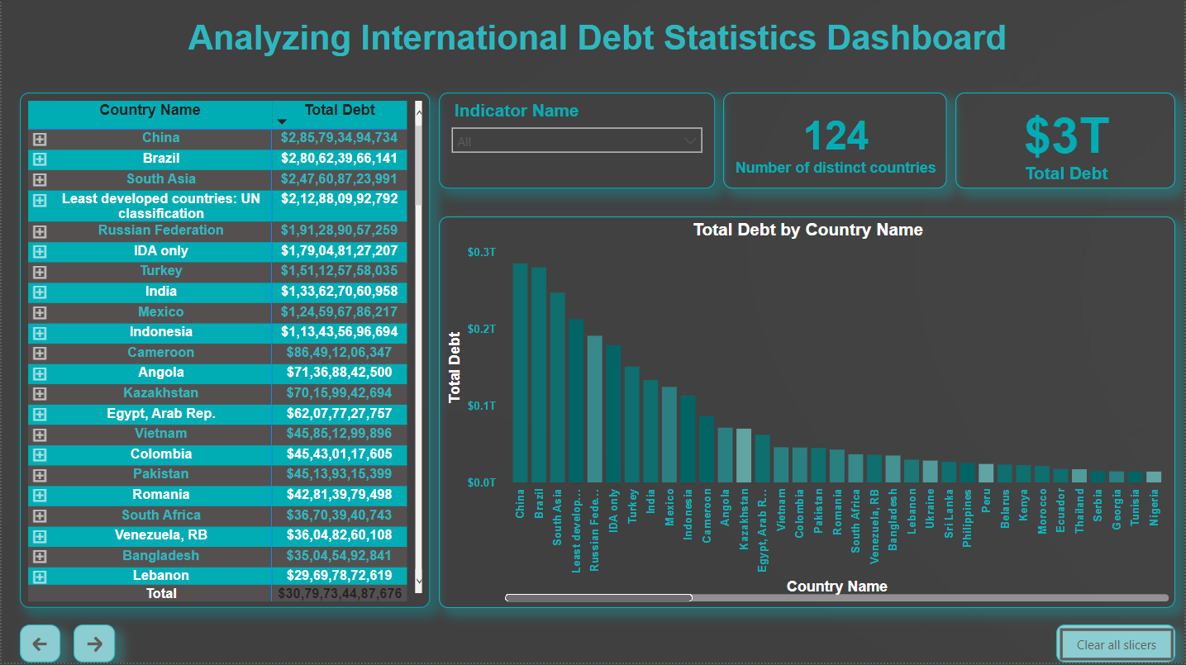

In the Dashboard, we interpreted the following results.

1. Indicator Code DT.AMT.DLXF.CD has the maximum sum of debt worth $96.0 bn (USD) and the maximum number of owed countries ranging up to 1.

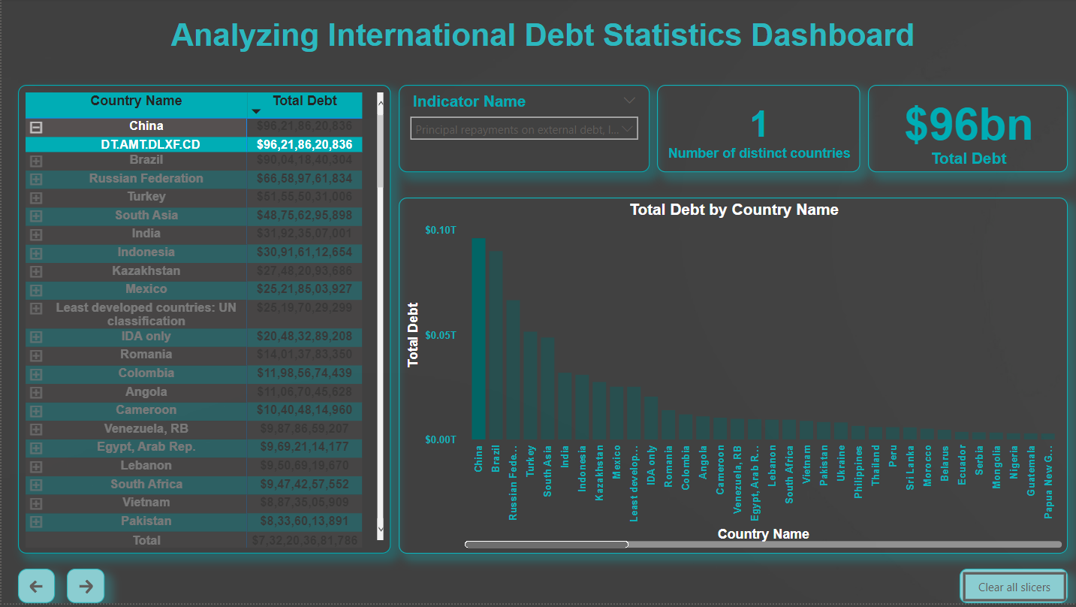

1. China is the one of the countries counting highest number of debts worth $ 286bn (USD) leading by country Brazil owing $ 281bn (USD). Summing over $ 566 bn (USD).

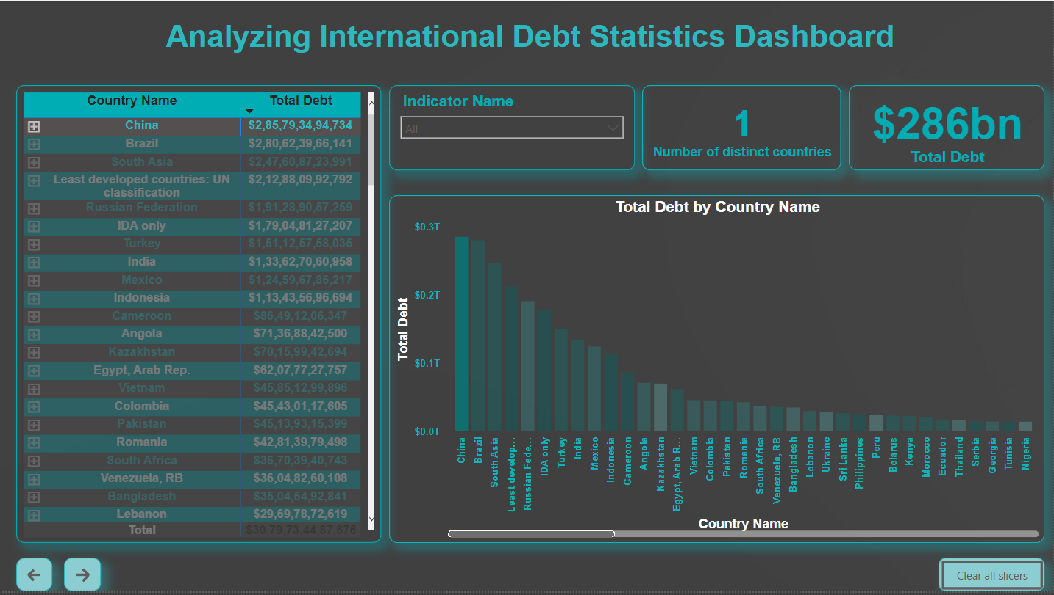

Country Name : China

Sum of debt : $ 285793494734

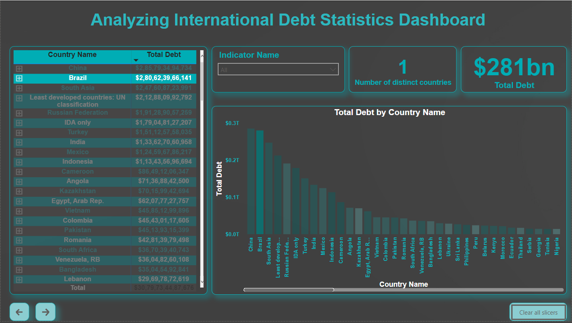

Country Name : Brazil

Sum of debt : $ 281793494734

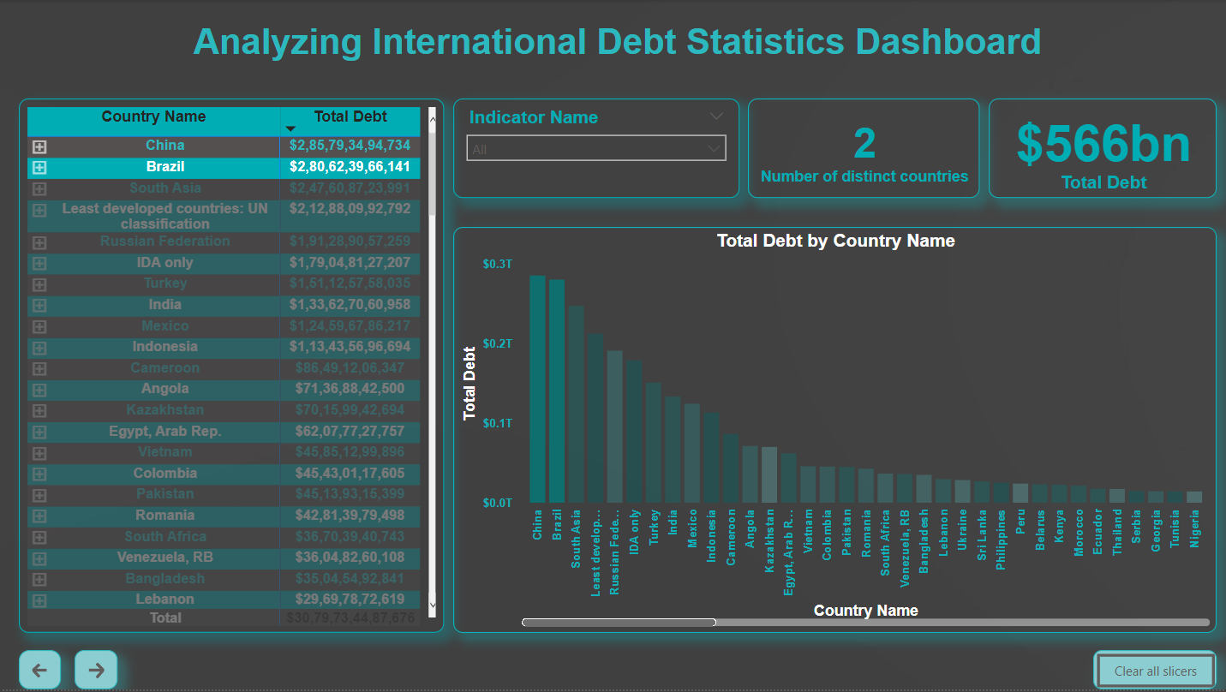

Country Name : China & Brazil

Sum of debt : $ 566417460875

Further Analysis

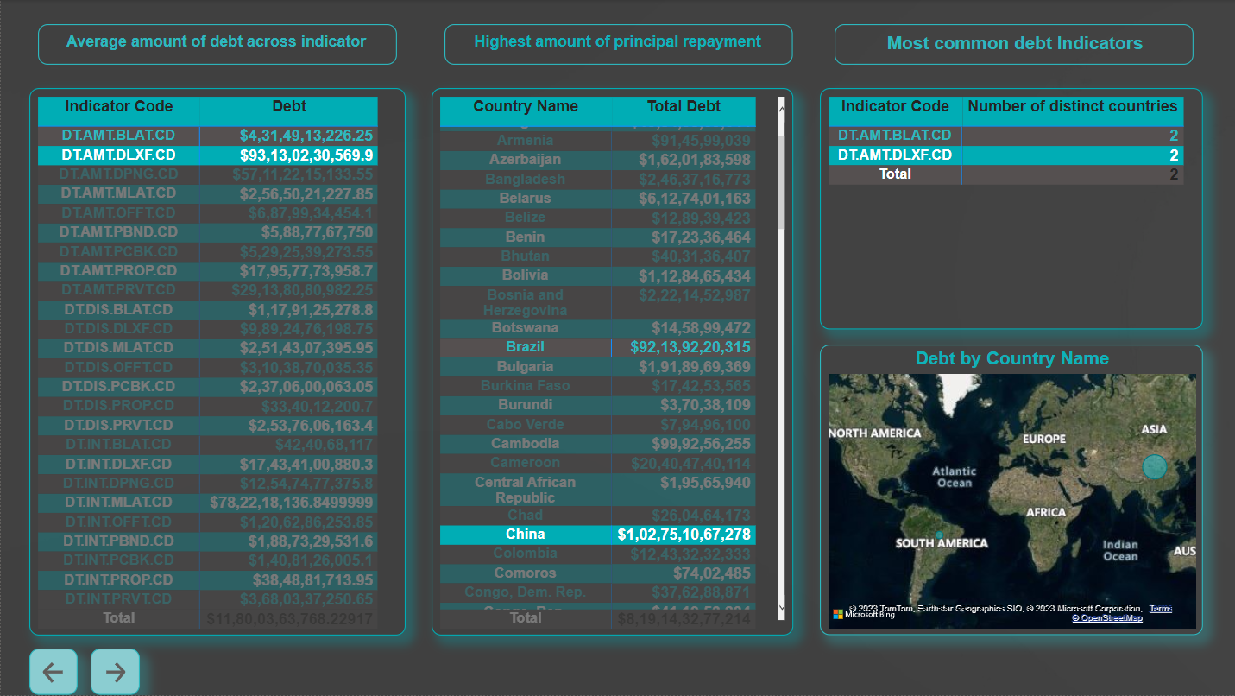

Further Analysis page has more emphasis on indicator codes.

Indicator Code DT.AMT.DLXF.CD and DT.AMT.DPNG.CD are the highest amount of average debt indicator counting to 2 times.

China and Brazil both are the owed with these indicators and with the highest amount of principal repayment.